PRDA-04
Job Market Analysis
Exploratory Data Analysis of U.S. Data Science Job Postings
Prepared by: S Suhaiyla Sulthana
Dataset: 742 job postings × 42 features
Source table: project_job_market_analysis.Market

Table of Contents
Executive Summary
1. Introduction & Data Overview
2. Geographic Analysis — States
3. Industry Analysis
4. Company Analysis
5. Job Title Analysis
6. Skills Required by Job Title
7. Salary vs. Education Requirement
8. Additional Insights
9. Recommendations & Suggestions
10. Interactive Dashboard — Power BI
11. Conclusion

Executive Summary
This report analyzes 742 data-science-related job postings across the United States, covering 42 attributes including salary, location, industry, company profile, required skills, and education preferences. The objective is to identify the most in-demand skills, qualifications, and job responsibilities, and to surface insights that help job seekers target the right roles/locations and help employers benchmark their compensation and hiring strategy.
Key headline findings:
- California, Massachusetts, New York and Virginia together account for roughly half of all postings, with California alone responsible for about 1 in 5 jobs and the highest average salary ($123.5K).
- Biotech & Pharmaceuticals is the single largest hiring industry (15% of postings), ahead of Insurance Carriers and Computer Hardware & Software — traditional 'IT Services' ranks only fourth.
- “Data Scientist” is the dominant title (42% of postings) and also one of the best paid roles ($118K average), but Machine Learning Engineer and Director-level titles command even higher average pay despite far fewer openings.
- Python, Excel and SQL are required in roughly half of all postings, making them the baseline toolkit; cloud/big-data skills (AWS, Spark) and BI tools (Tableau) are the next tier of differentiation.
- Education requirements move the needle on pay: postings asking for a PhD pay 22% more on average than postings with no explicit degree requirement, and 10% more than Master's-level postings.
- Company rating, founding age and revenue show only weak correlation with salary — meaning compensation is driven far more by role, industry and location than by 'brand prestige' alone.

1. Introduction & Data Overview
The dataset consists of 742 job postings, each described by 42 features spanning job identity (Job Title, Job Description), compensation (Salary Estimate, Lower/Upper Salary, Avg Salary(K), Hourly, Employer Provided), company profile (Company Name, Rating, Headquarters, Size, Founded, Type of Ownership, Industry, Sector, Revenue, Competitors), location (Location/Job Location), and a set of engineered fields: 16 binary skill flags (Python, Spark, AWS, Excel, SQL, SAS, Keras, PyTorch, Scikit-learn, TensorFlow, Hadoop, Tableau, BI, Flink, MongoDB, Google Analytics), a simplified job title (job_title_sim), a seniority flag derived from the title, and a Degree flag indicating whether the posting credits a Master's (M) or PhD (P).

1.1 Data Source
Data was retrieved from the project's MySQL database (table: Market, database: project_job_market_analysis) using SQLAlchemy/pymysql, matching the standard pandas + SQLAlchemy stack used across this training program's projects.

1.2 Handling of Missing Values (-1 placeholders)
Per the dataset notes, a value of -1 denotes missing information. The following imputation strategy was applied:
- Rating: 11 postings (1.5%) had -1; imputed with the dataset median rating (3.7) so summary statistics aren't distorted by a sentinel value.
- Founded / Age: 50 postings (6.7%) had -1 (company founding year unknown); left as missing (NaN) rather than imputed, since fabricating a founding year would bias age-based analysis. These rows are excluded only from age-specific charts, not from the rest of the analysis.
- Competitors: 460 postings (62%) had -1, simply meaning no competitor data was available for that listing; recoded to "Not Disclosed" rather than dropped, since this is a legitimate "unknown" category, not noise.
- Industry / Sector: 10 postings each had -1; recoded to "Not Disclosed" and excluded from the industry/sector ranking charts so they don't appear as a fake top category.

2. Geographic Analysis — States

2.1 States with the Most Job Postings
California leads by a wide margin with 152 postings (20.5% of the dataset), followed by Massachusetts (103), New York (72), Virginia (41) and Illinois (40). Together, the top four states account for roughly 50% of all postings nationwide — unsurprising given California's concentration of tech employers, but notable that Massachusetts (driven by biotech/pharma and academic medical centers) outranks New York.
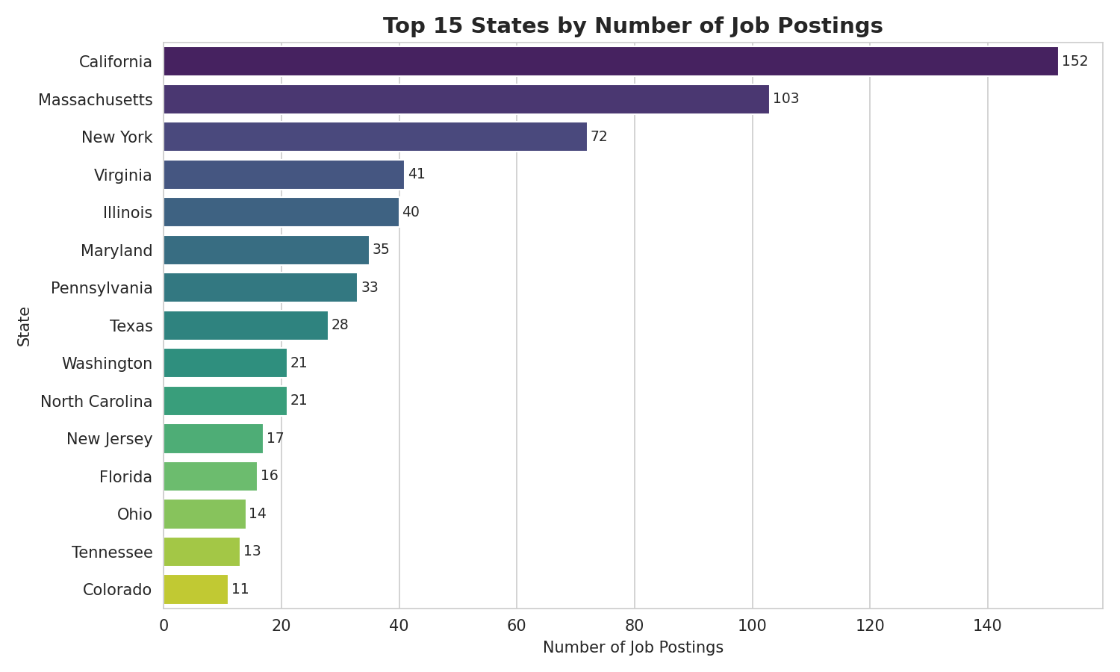
Figure 2.1 — Top 15 states by number of job postings

2.2 Average Minimum & Maximum Salary by State
California offers both the highest average minimum salary ($92.4K) and highest average maximum salary ($154.6K) among the top states by job count, with Illinois a close second on both measures ($88.4K / $145.0K). Pennsylvania has the lowest average minimum salary among the top 10 states ($67.1K), while Washington has the lowest average maximum salary among them ($115.3K) despite its tech-hub reputation.
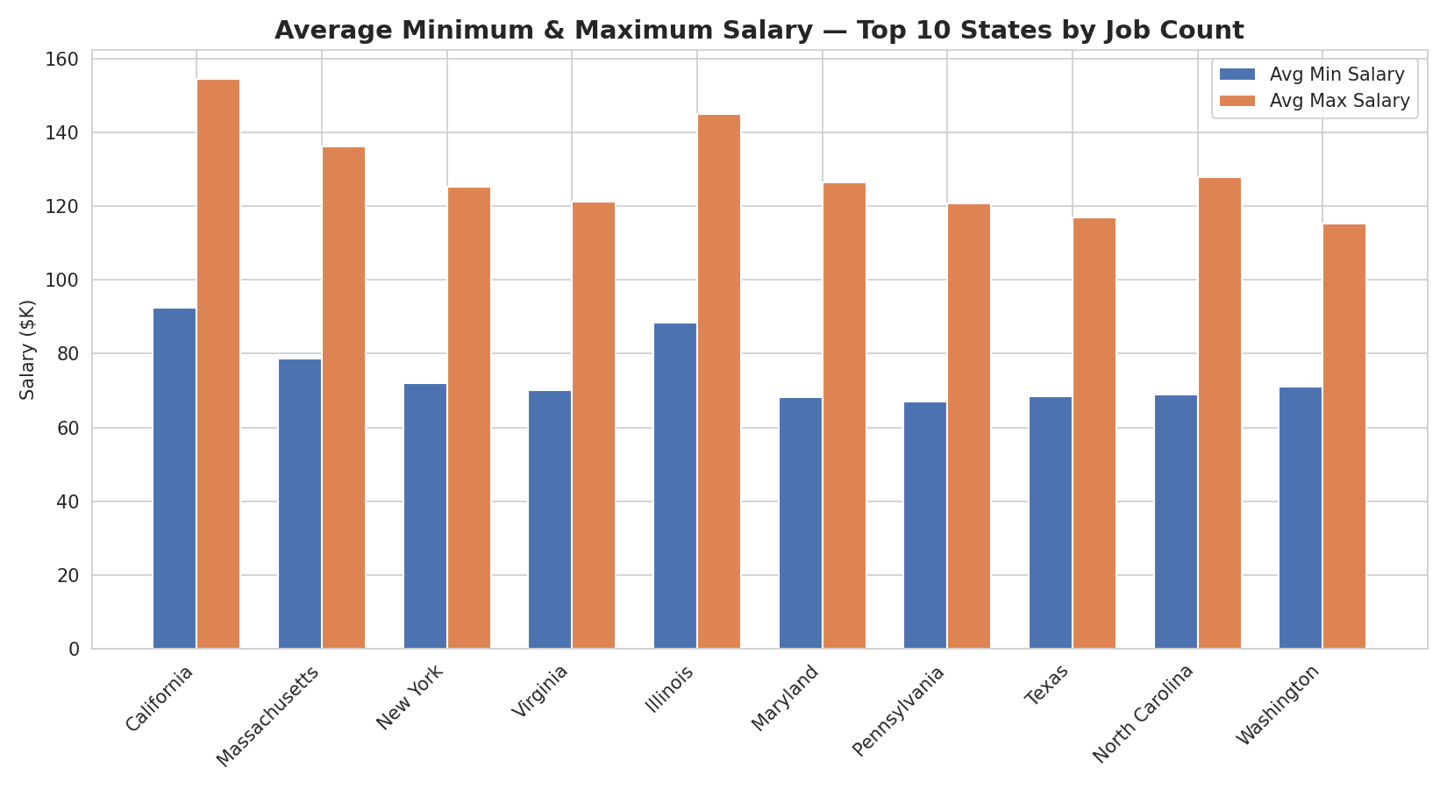
Figure 2.2 — Average minimum and maximum salary, top 10 states by job count

2.3 Average Salary by State
Looking at average salary (the midpoint of min/max), California again tops the list at $123.5K, followed by Illinois ($116.7K) and Washington D.C. ($110.2K). Among states with a meaningful sample size, Florida ($77.6K) and Ohio ($87.6K) sit at the lower end; nationally, Nebraska has the lowest average salary at $54.2K, though on a very small sample.
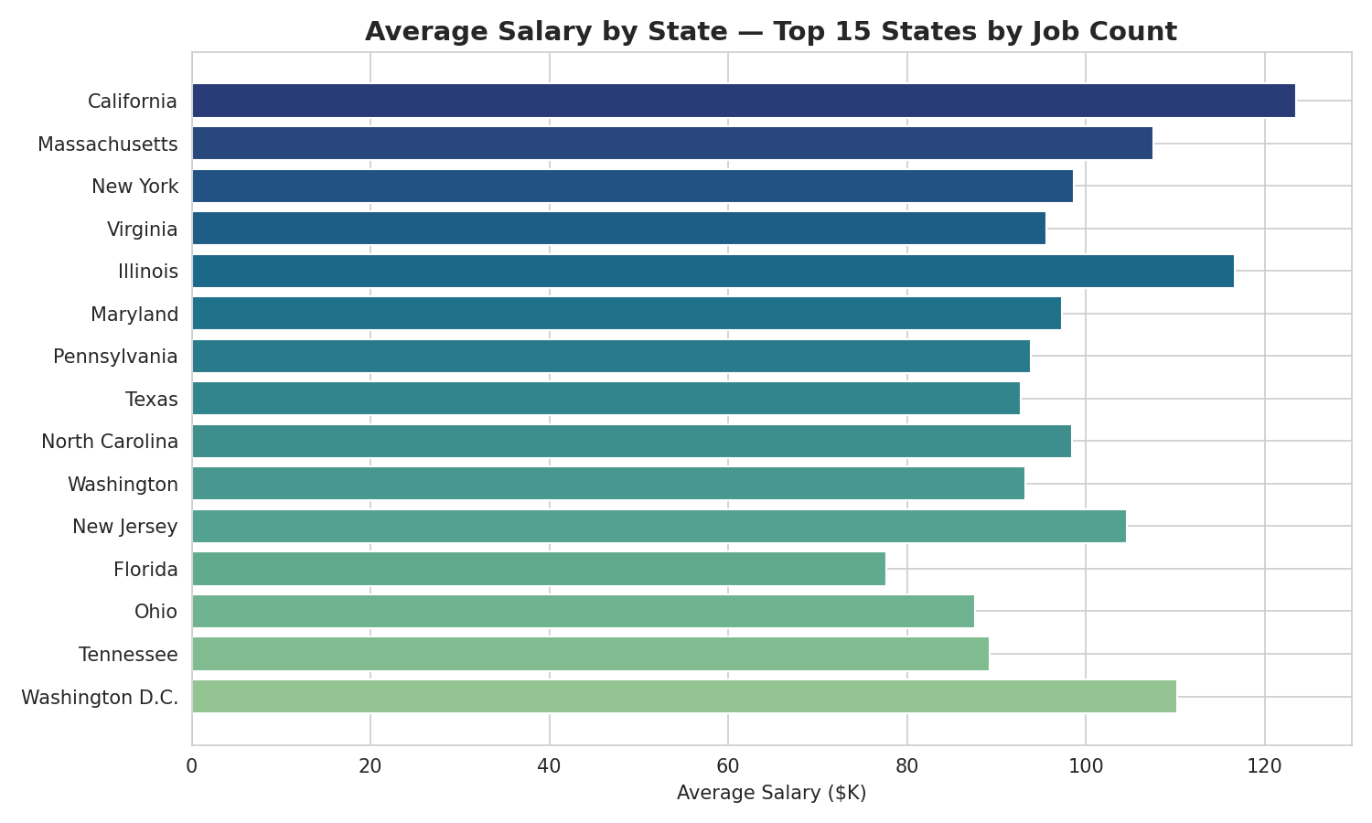
Figure 2.3 — Average salary by state, top 15 states by job count

3. Industry Analysis

3.1 Top Industries by Job Postings
Biotech & Pharmaceuticals is the single largest source of data-science job postings (112 postings, 15.1%), followed by Insurance Carriers (63), Computer Hardware & Software (59), IT Services (50) and Health Care Services & Hospitals (49). Together, the top 10 industries account for 65% of all postings — a useful signal that data science hiring is concentrated, not evenly spread, across the economy. Notably, the canonical 'IT Services' sector ranks only fourth, behind two life-sciences-adjacent industries.
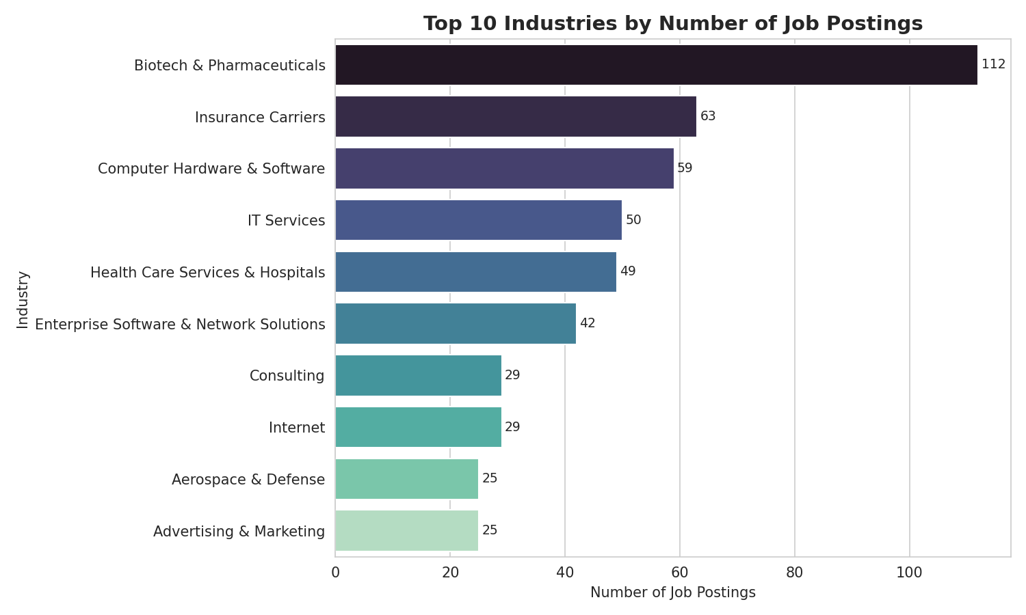
Figure 3.1 — Top 10 industries by number of job postings

3.2 Salary by Top 5 Industries
Computer Hardware & Software offers the highest average minimum ($84.9K) and maximum ($145.5K) salary among the top 5 industries, narrowly ahead of Biotech & Pharmaceuticals ($79.9K / $144.4K). Health Care Services & Hospitals pays noticeably less than the other four leading industries (average min/max of $56.3K / $97.8K) — despite having a large volume of postings, suggesting many of these roles are lower-seniority analyst positions rather than senior data science roles.
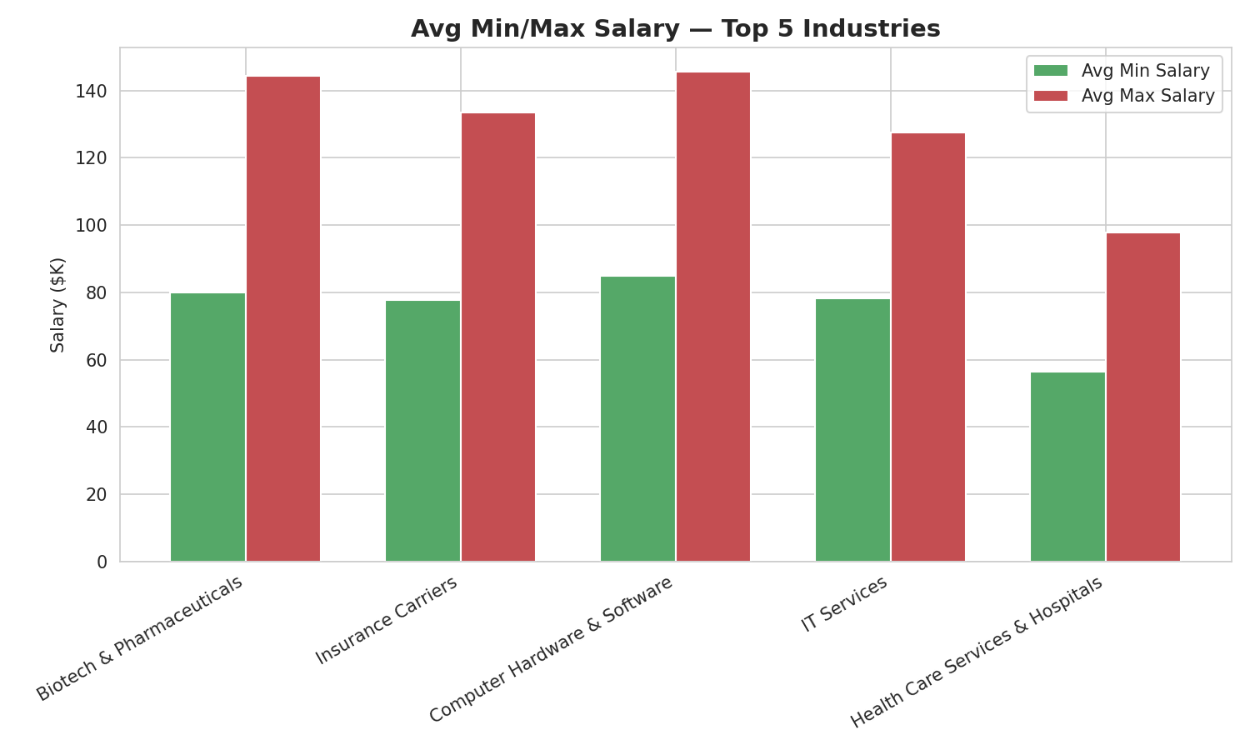
Figure 3.2 — Average minimum/maximum salary across the top 5 industries

4. Company Analysis
The dataset spans 343 distinct companies, meaning most employers post only one or two roles — there is no single dominant employer. Takeda Pharmaceuticals, MassMutual and Reynolds American tie for the most postings (14 each), followed by Software Engineering Institute (11) and Pacific Northwest National Laboratory / PNNL (10). The presence of two pharmaceutical companies and an insurer in the top 5 again reinforces the biotech/insurance hiring pattern seen at the industry level.
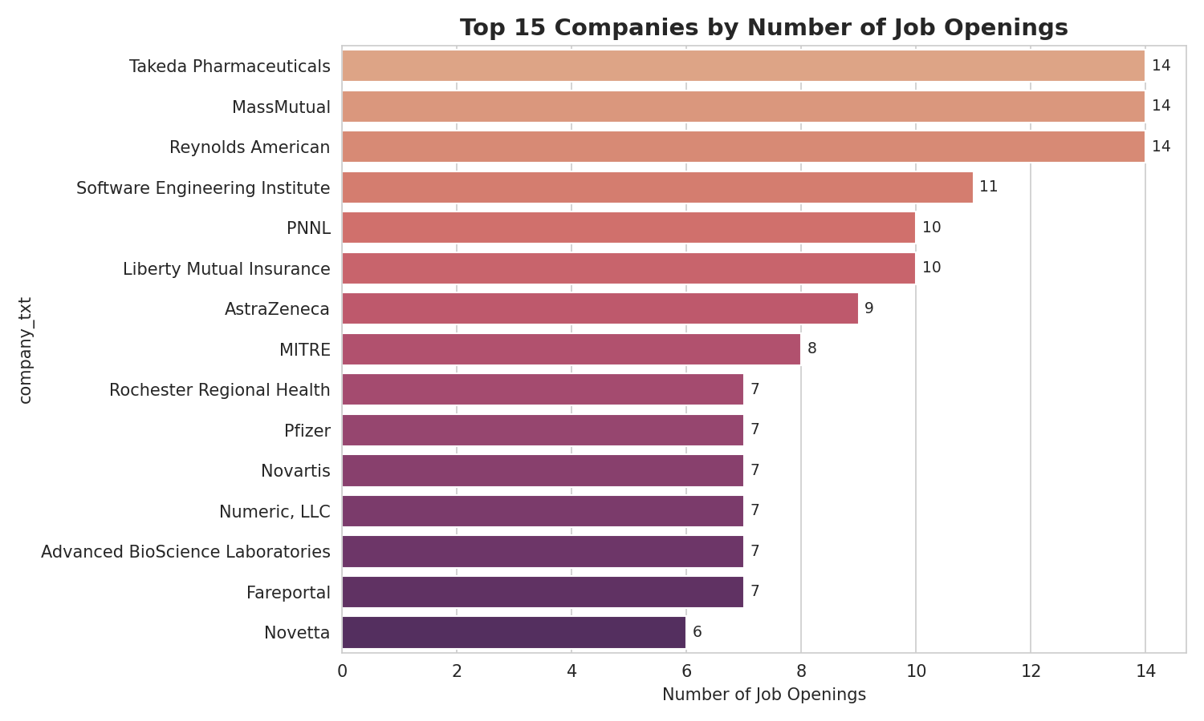
Figure 4.1 — Top 15 companies by number of job postings

4.1 Ownership Type
Privately held companies post the most data science roles (410 postings, 55%), followed by publicly traded companies (193, 26%). Nonprofits, subsidiaries, government bodies, hospitals and academic institutions make up the remaining ~19%, indicating that while private/public corporations dominate, there is meaningful demand from mission-driven and public-sector organizations too.
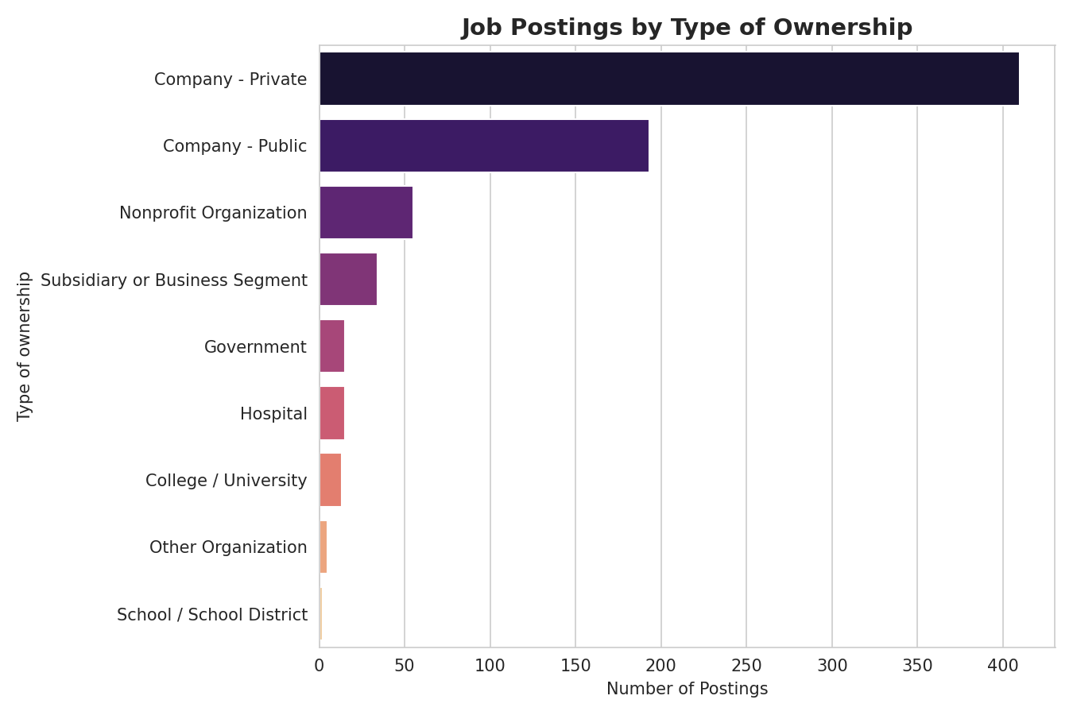
Figure 4.2 — Job postings by type of ownership

4.2 Company Size & Revenue vs. Salary
Average salary rises with company size up to a point: the smallest companies (1-50 employees, often startups) and the largest (10,000+ employees) both pay above the dataset average, while mid-sized companies (501-5,000 employees) pay somewhat less. This is consistent with a common labor-market pattern — large enterprises can pay premium salaries for scale, and small startups pay premium equity-adjacent cash salaries to compete for talent, while the 'middle' tier is more cost-conscious.
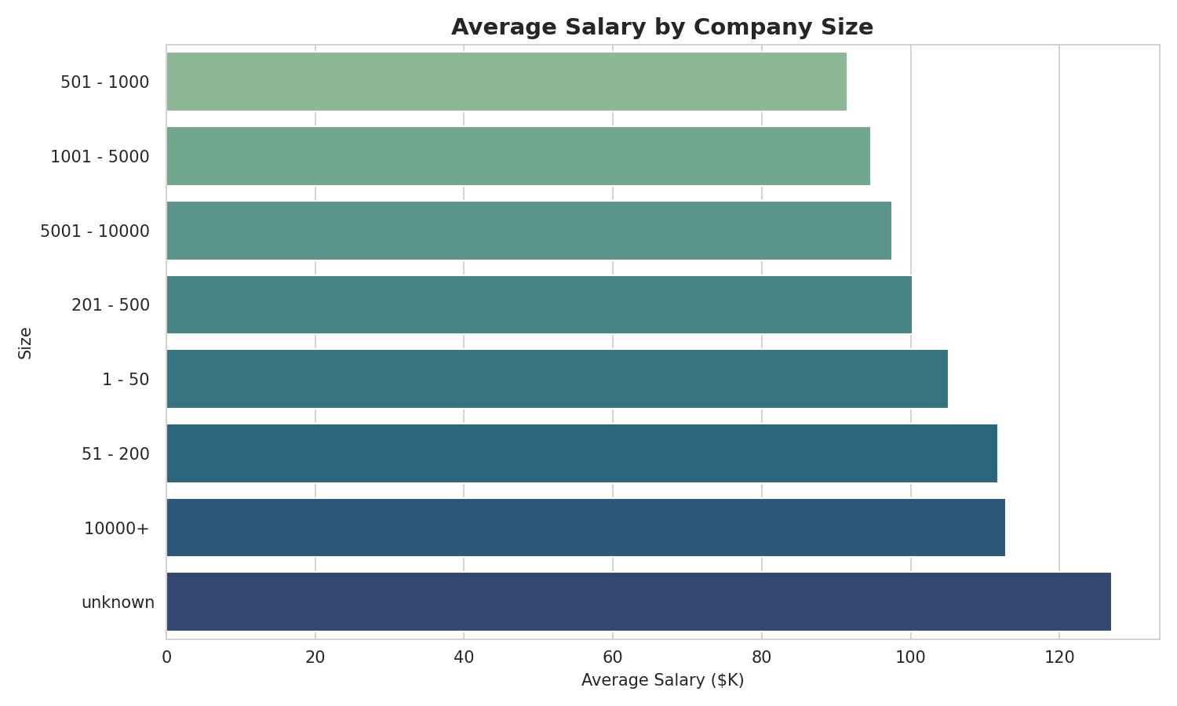
Figure 4.3 — Average salary by company size band
Revenue shows a similar non-linear pattern: companies in the $5-10 million revenue band pay the most on average ($126.1K), ahead of even $10B+ enterprises ($115.6K), while companies in the $25-50 million band pay the least ($82.8K) among bands with a reasonable sample size. This likely reflects a mix of well-funded niche/specialist firms in the smaller-revenue brackets paying competitively for scarce talent.
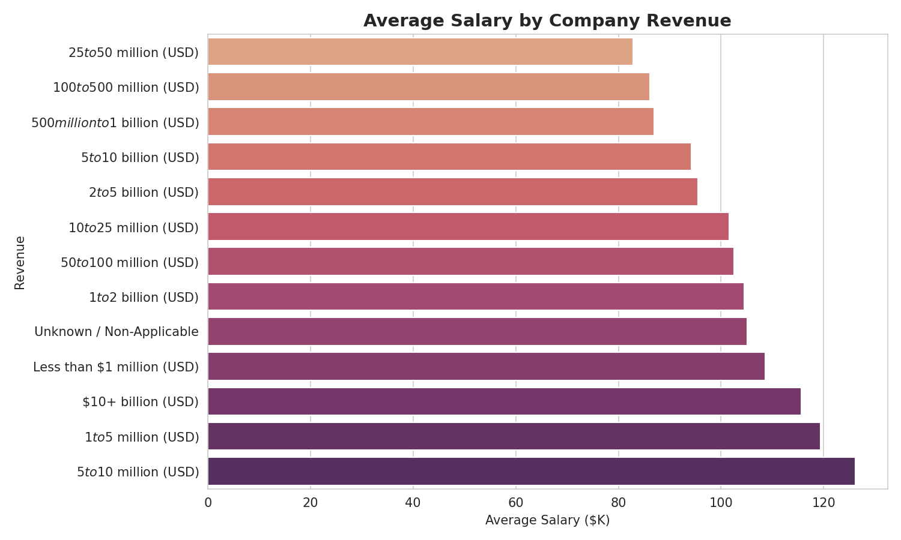
Figure 4.4 — Average salary by company revenue band

5. Job Title Analysis

5.1 Job Titles with the Most Postings
Data Scientist is by far the most common simplified job title (313 postings, 42.2%), followed by 'Other Scientist' roles such as research scientists (143, 19.3%), Data Engineer (119, 16.0%) and Analyst (101, 13.6%). These four titles alone account for over 90% of postings; Machine Learning Engineer, despite being a high-profile title in the industry, represents only 22 postings (3.0%).
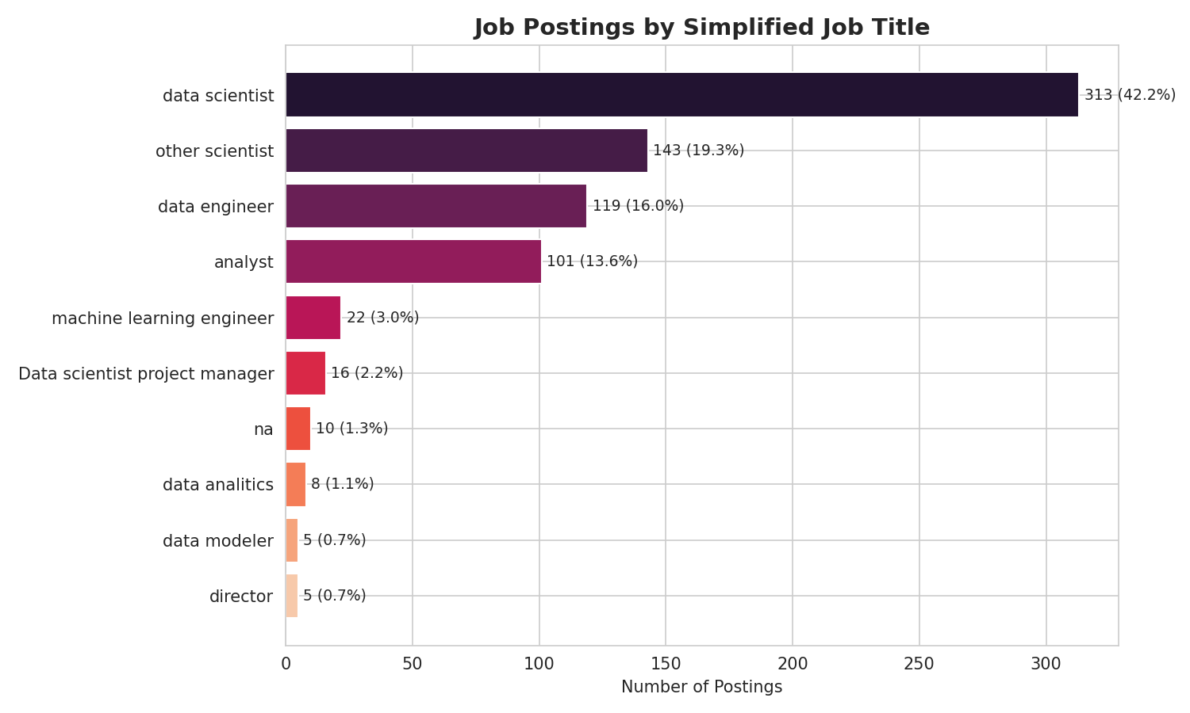
Figure 5.1 — Job postings by simplified job title

5.2 Salary by Job Title
Director-level roles command the highest average salary ($130.8K), followed closely by Machine Learning Engineer ($126.4K) and Data Scientist ($118.3K) — despite ML Engineer postings being far rarer than Data Scientist postings, the per-role pay premium is real. Analyst roles pay considerably less on average ($66.1K), reflecting their typically more junior scope. Data Engineer sits in between ($105.4K), confirming that engineering-adjacent data roles are paid closer to data science than to traditional analyst roles.
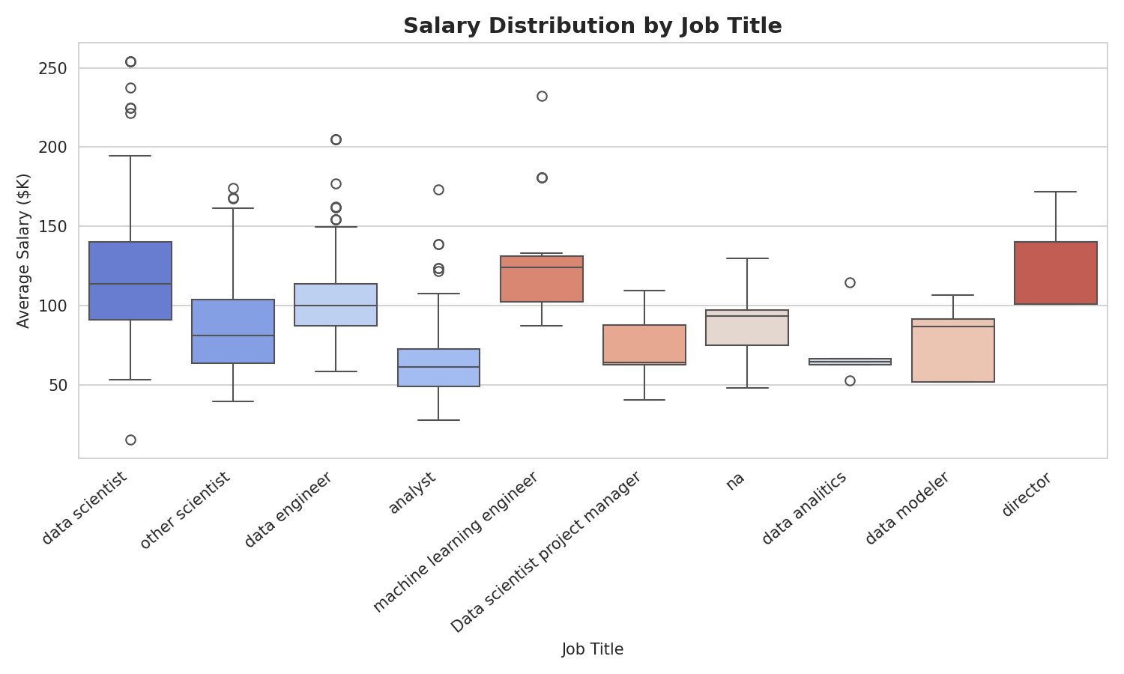
Figure 5.2 — Salary distribution by job title (box plot)

6. Skills Required by Job Title
Across all 742 postings, Python (52.8%), Excel (52.3%) and SQL (51.2%) are the three most commonly required skills — each appears in roughly half of all postings, making them the de facto baseline toolkit for any data role in this market. AWS (23.7%) and Spark (22.5%) form a clear second tier tied to cloud/big-data infrastructure, with Tableau (19.9%) representing the leading BI/visualization tool. Niche deep-learning frameworks (Keras 3.9%, PyTorch 5.3%) and streaming tools (Flink 1.3%) remain rare, suggesting most employers prioritize core data manipulation and SQL fluency over specialized ML engineering tooling.
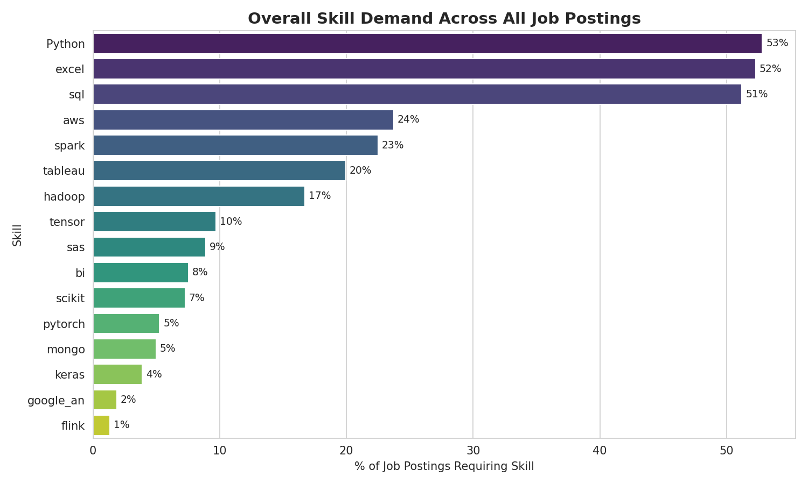
Figure 6.1 — Overall skill demand across all job postings
Breaking this down by job title reveals sharp specialization:
- Machine Learning Engineer postings have the highest Python requirement of any title (82%) and are the only group with meaningful PyTorch (32%) and TensorFlow (41%) demand — confirming this title is the most deep-learning-specific role in the dataset.
- Data Engineer postings lead on Spark (56%), AWS (50%) and Hadoop (42%) — the classic big-data infrastructure stack — far ahead of every other title.
- Analyst postings have the highest Excel (76%) and Tableau (40%) requirements, alongside the highest Google Analytics demand (11%) — confirming this title skews toward business/BI-style analysis rather than engineering or modeling.
- Data Scientist postings sit in the middle of almost every skill column, reflecting the title's broad, generalist scope spanning Python, SQL, Excel and a moderate amount of Spark/AWS.
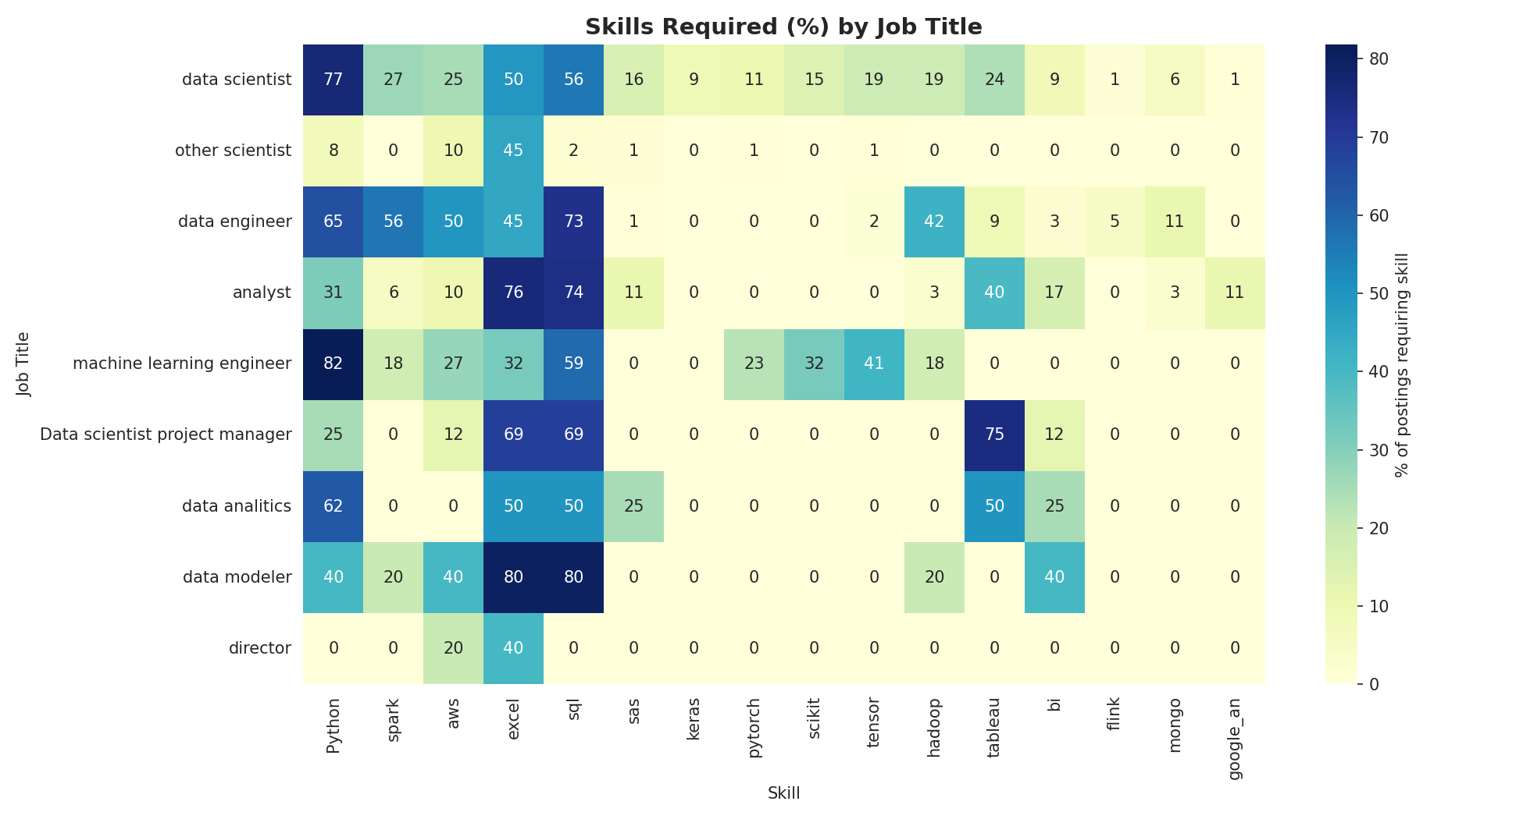
Figure 6.2 — Heatmap of skill demand (%) by job title

7. Salary vs. Education Requirement
383 postings (51.6%) make no explicit mention of a degree credit, 252 (34.0%) credit a Master's degree, and 107 (14.4%) credit a PhD. Average salary rises steadily with the stated education preference: $94.7K for postings with no specific requirement, $105.6K for Master's-credited postings (+12%), and $116.0K for PhD-credited postings (+22% vs. no-requirement, +10% vs. Master's).
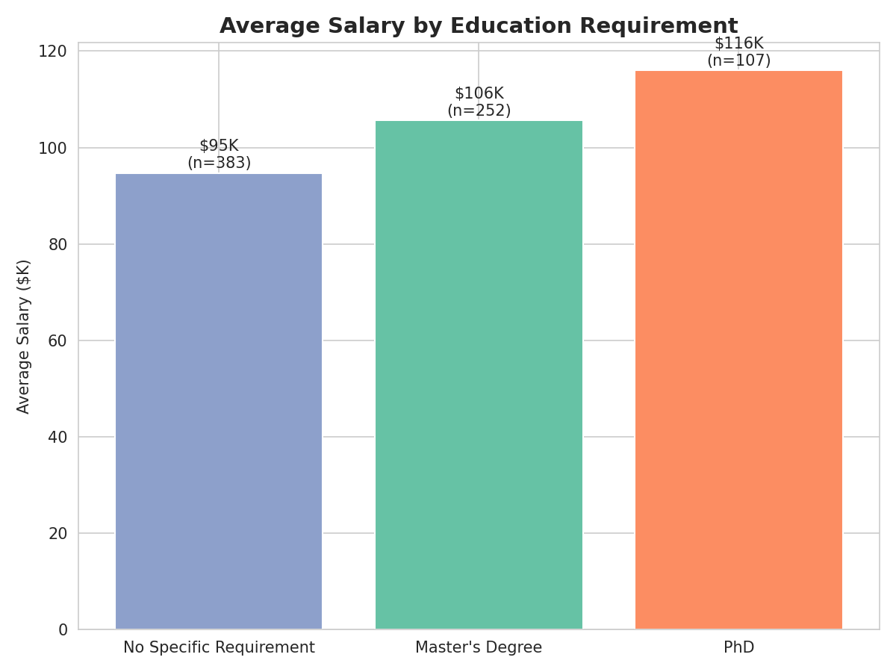
Figure 7.1 — Average salary by education requirement
The pattern holds when looking at the full salary distribution rather than just the average — PhD-credited postings are shifted upward across the board, not just at the high end, suggesting employers structurally pay more for postings where doctoral-level expertise is explicitly valued (commonly research scientist and senior data scientist roles).
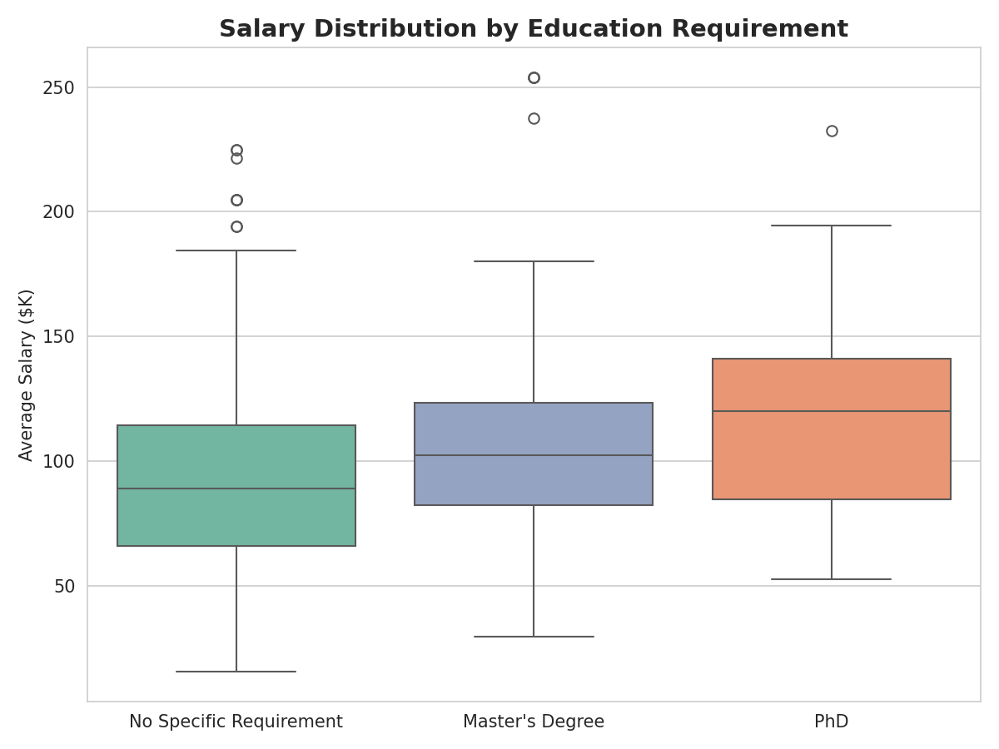
Figure 7.2 — Salary distribution by education requirement

8. Additional Insights

8.1 Seniority
Job titles explicitly flagged as Senior pay substantially more on average ($121.7K, n=220) than postings with no seniority indicator in the title ($93.1K, n=519). Only 3 postings carried an explicit 'Junior' flag, too small a sample to draw firm conclusions, but directionally consistent with lower pay ($71.0K).
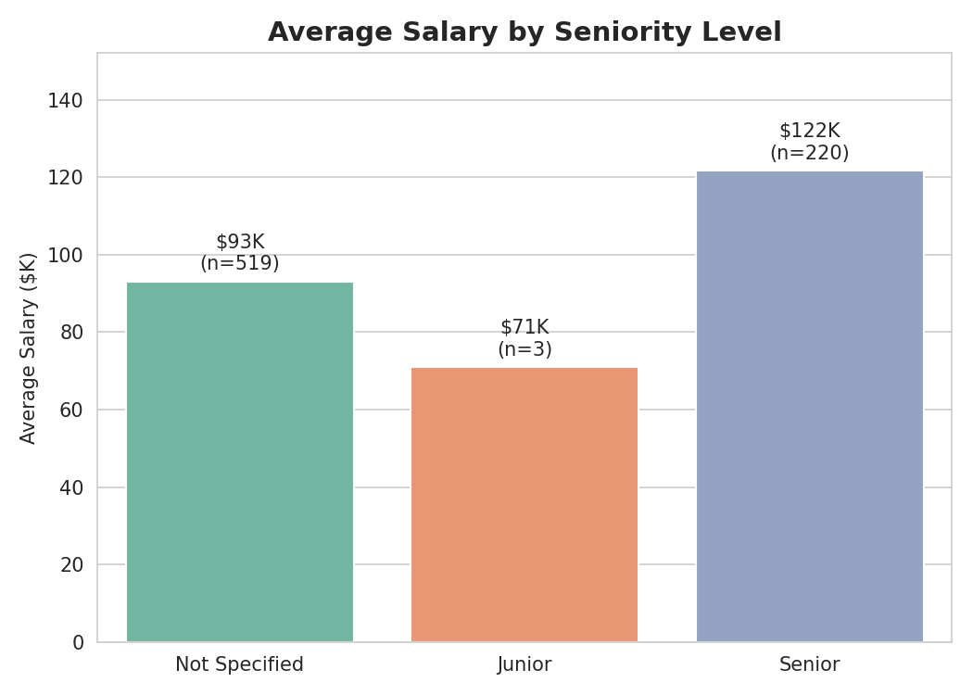
Figure 8.1 — Average salary by seniority level

8.2 Company Rating & Age
Company rating shows only a weak positive correlation with average salary (r = 0.13), and company age shows essentially no correlation (r = 0.03). In other words, neither how well-reviewed nor how old/established a company is meaningfully predicts how much it pays for data roles — compensation is driven far more by role, industry, and location, as shown in earlier sections.
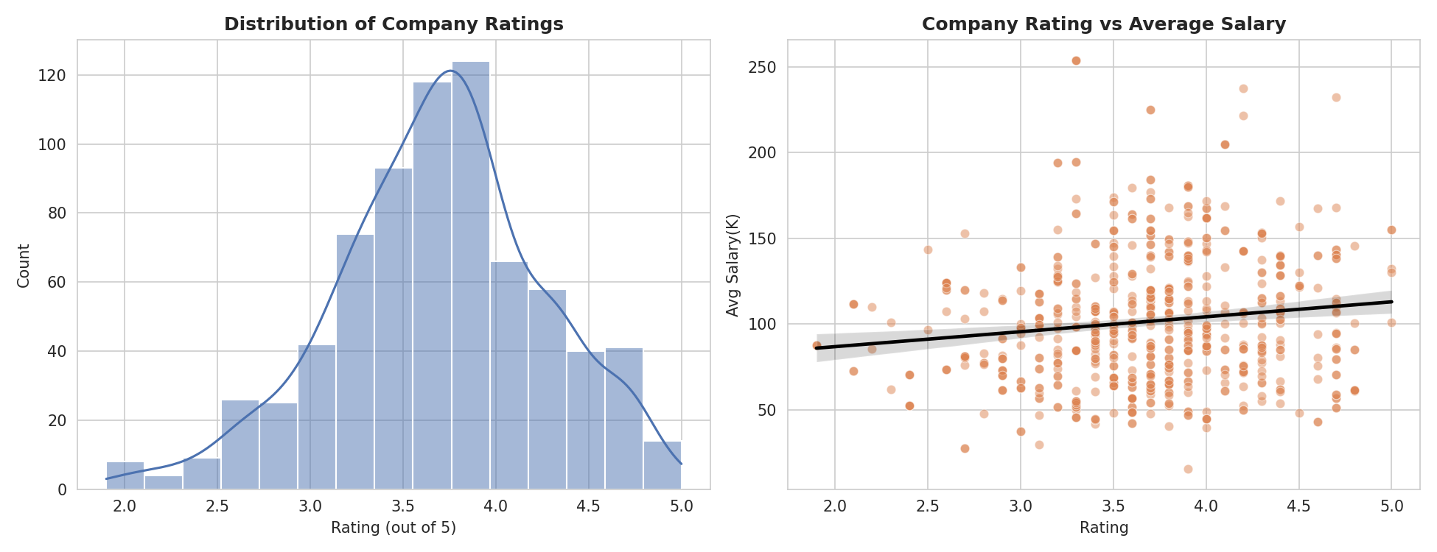
Figure 8.2 — Distribution of company ratings, and rating vs. average salary

8.3 Hourly vs. Annual & Employer-Provided Estimates
The vast majority of postings (718 of 742, 96.8%) report annual salary rather than an hourly rate, and only 17 postings (2.3%) have an employer-provided salary figure rather than an estimated one — meaning the salary analysis in this report is overwhelmingly built on estimated salary data rather than self-reported employer data, a useful caveat for interpreting absolute salary levels.

8.4 Job Title Mix Across Top States
The mix of roles being hired varies meaningfully by state. California's postings are split fairly evenly between Data Scientist (~49%) and Data Engineer roles, with a small but present Machine Learning Engineer share (~3%). Massachusetts skews much more toward 'Other Scientist' roles than any other top state, consistent with its concentration of biotech/pharma R&D employers, while Virginia and Illinois lean more heavily toward Data Scientist and Data Engineer titles, with little presence of niche titles.
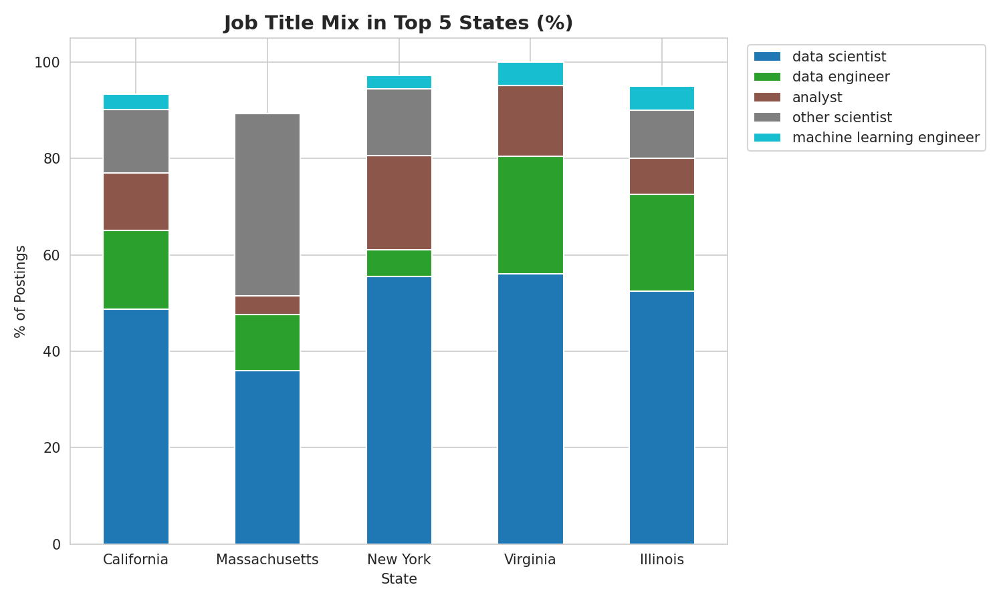
Figure 8.3 — Job title mix (%) within each of the top 5 states

9. Recommendations & Suggestions

9.1 For Job Seekers
- Build a baseline of Python, SQL and Excel first — these appear in roughly half of all postings regardless of specific job title, making them the highest-leverage skills to learn before anything specialized.
- If targeting Machine Learning Engineer roles specifically, prioritize PyTorch/TensorFlow and deep Python fluency; if targeting Data Engineer roles, prioritize Spark, AWS and Hadoop instead — the two titles have almost opposite skill profiles despite both being 'data' roles.
- A PhD or Master's credential is associated with a real, measurable salary premium (10-22%) in this market, particularly for Data Scientist and 'Other Scientist' (research scientist) titles — worth factoring into long-term career planning if targeting the highest-paying segment.
- California, Massachusetts, New York, Virginia and Illinois together host roughly 60% of postings in this dataset — job seekers with geographic flexibility should prioritize these markets for both volume and pay.

9.2 For Employers / Hiring Companies
- Benchmark Data Scientist compensation against the $90K-$146K (avg min-max) range observed here; offers meaningfully below this band are likely to underperform in a competitive market, especially in California, Illinois, and Washington D.C.
- Consider that company rating and brand age do not meaningfully influence candidates' likely salary expectations in this data — meaning smaller or newer companies are not at a structural disadvantage on pay alone and can compete on role scope, growth, and culture instead.
- Mid-sized companies (501-5,000 employees) currently pay below both larger and smaller peers; if experiencing hiring difficulty in this size band, a compensation review relative to the $91K-$98K average observed here is warranted.
- Given that Excel and Tableau remain dominant skill requirements alongside Python/SQL, hiring pipelines for 'Analyst' titles should weight BI tool fluency at least as heavily as programming ability — these roles are structurally different from Data Scientist/Engineer hiring needs.

10. Interactive Dashboard — Power BI
While the charts in this report were produced in Python (pandas, matplotlib, seaborn) for the EDA phase, the findings were also rebuilt as a four-page interactive Power BI dashboard on the same cleaned dataset, allowing a non-technical viewer to filter and drill down by state, job title, seniority and education requirement without writing any code. Every page shares a synchronized set of slicers (State, Job Title, Seniority, Degree) plus a Reset Slicers control, so a filter applied on one page carries through to the rest of the dashboard.

10.1 Overview
The landing page surfaces the headline numbers (742 total postings, 343 companies, 37 states, $101.5K average salary) alongside the top hiring states, the seniority split, jobs by location, and the top hiring industries — giving a first-glance summary before drilling into any one dimension.
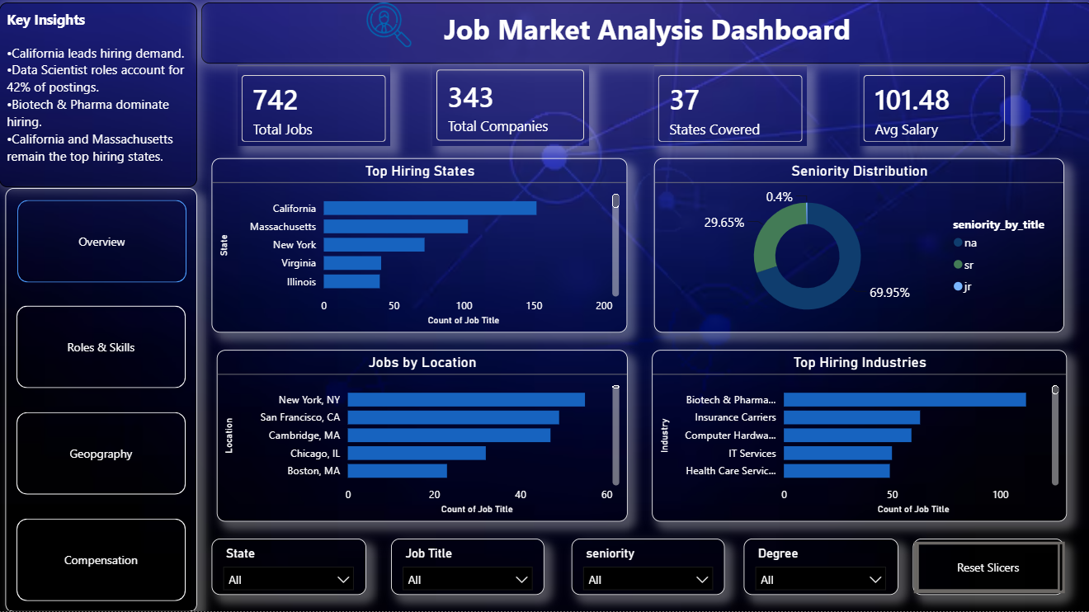
Figure 10.1 — Dashboard: Overview page

10.2 Roles & Skills
This page operationalizes the job-title and skills analysis from Sections 5 and 6: job postings and average salary by title side by side, a skill-demand treemap, the skills-required-by-job-title matrix (the live equivalent of Figure 6.2), and the top 15 skills overall — all filterable by job title, seniority or degree.
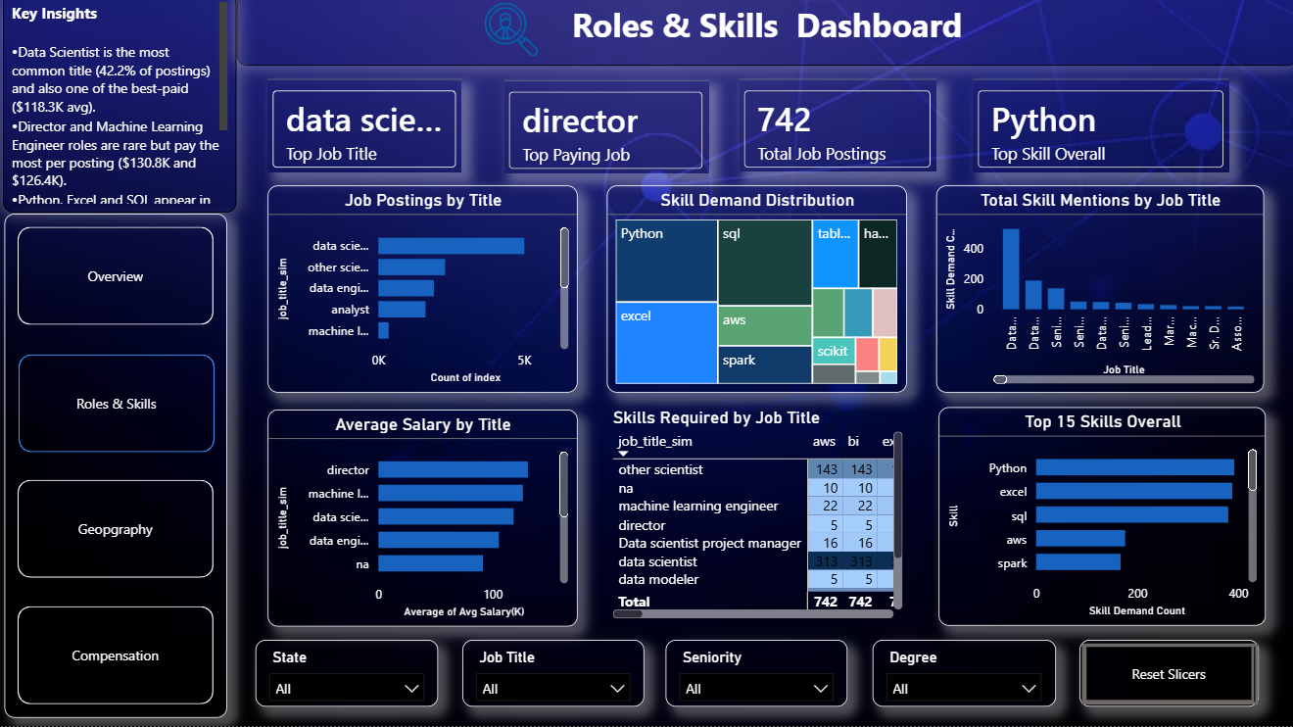
Figure 10.2 — Dashboard: Roles & Skills page

10.3 Geography
This page operationalizes the state-level analysis from Section 2 plus the industry/company findings from Sections 3-4: top companies, average minimum vs. maximum salary by state, a U.S. map of hiring distribution, top industries, and top sectors by job count — letting a viewer click any state and see the rest of the dashboard's industry and company breakdown update accordingly.
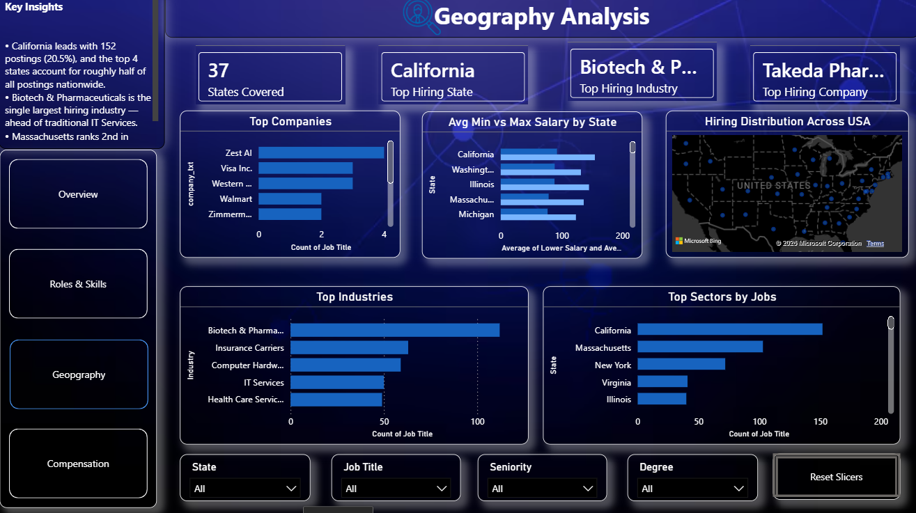
Figure 10.3 — Dashboard: Geography page

10.4 Compensation
This page operationalizes Section 7 (education vs. salary) and the compensation-driver findings from Section 8: salary by education requirement, average salary by state, a rating-vs-salary trend, salary by seniority level, salary by company size, and salary by revenue band — bringing every salary driver covered in this report into one filterable view.
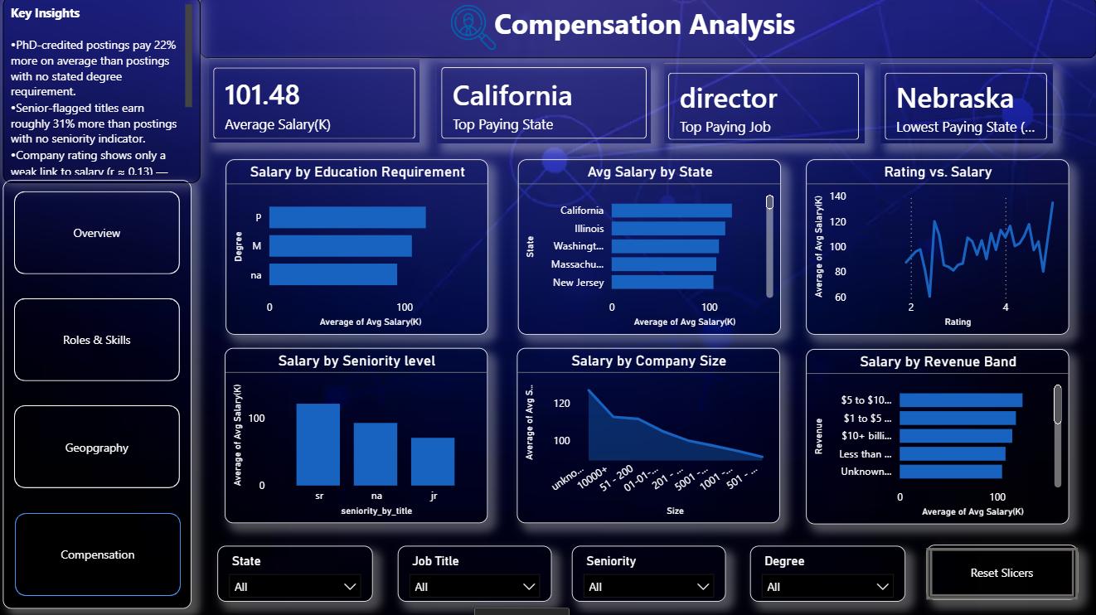
Figure 10.4 — Dashboard: Compensation page
This phased approach — Python for deep, reproducible EDA and statistical rigor, then Power BI for stakeholder-facing self-service exploration — mirrors standard industry practice. The .pbix file accompanies this report as a separate submission.

11. Conclusion
This analysis of 742 data science job postings shows a labor market that is geographically concentrated (California, Massachusetts, New York, Virginia and Illinois dominate volume and pay), industry-concentrated (Biotech & Pharmaceuticals and Insurance Carriers outweigh traditional IT Services), and role-specific in its skill demands (Data Engineer and Machine Learning Engineer postings require almost opposite toolkits despite both being 'data' titles). Compensation is most strongly driven by job title, industry, location and stated education requirement — and only weakly related to company rating, age or revenue. These findings give job seekers a concrete prioritization framework (skills, credentials, and geography) and give employers a benchmarking framework (role-appropriate pay bands, by state and industry) grounded directly in current market data.

Report prepared as part of the PRDA-04 Job Market Analysis project.

